**NATIONAL-PARKS**

**E-Project Documentation**

**Teacher Name: SYEDA IMAMA**

**APTECH COMPUTER EDUCATION**

**HYDERABAD-1 PAKISTAN**

**Issue Date:    09-Jul-2023**

TABLE OF CONTENT

|  |  |  |
| --- | --- | --- |
| **S No** | **Contents** | **Page No** |
| 01 | Certificate | 3 |
| 02 | Acknowledgement | 4 |
| 03 | Project Report | 5 |
| 04 | Problem Definition | 6 |
| 05 | Customer Requirements Specification (CRS) | 7 |
| 06 | Architecture Design of the Project | 8 |
| 07 | System Requirement | 9 |
| 08 | Task Sheet | 10 |
| 09 | Project Plan | 11 |
| 10 | Checklist of work Progress | 12 |
| 11 | Final Check List | 13 |
| 12 | Screen Shots | 14 |
| 13 | Source Code | 16 |

CERTIFICATE

This is to certify that

**ABDUL BASIT SHAIKH**

Submitted by:

**ABDUL BASIT SHAIKH**

Has successfully Designed

NATIONAL PARKS

Date of Issue: 09-JULY-2023

Authorized Signature: SYEDA IMAMA

ACKNOWLEDGEMENT

First and foremost, we would like to express our deep gratitude and most heartfelt thanks to almighty ALLAH for his blessings, for lightening up our heart with the torch of knowledge and for giving us the ability to complete this project.

We would like to thanks Aptech Worldwide and the team of E-Project for their generous support and clarifying the doubts regarding e-project. We would like to acknowledge the way of explanation which the team of e-project gave in e-project to make website and we are equally grateful to our teacher (Sir Jahanzaib) for giving us a moral support and guiding us different matters regarding project in all the time about the research and writing of this project.

We are greatly indebted to Aptech Worldwide, SIR Jahanzaib, Faculty Members and ACE Hyderabad, Pakistan for encouragement and incessant help.

PROJECT REPORT

**By:**

|  |  |
| --- | --- |
| **Student1452620** | **Abdul Basit Shaikh** |

Project Title: NATIONAL-PARKS

Member Name: ABDUL BASIT SHAIKH

Batch Code: 2301E

Start Date: 09-JULY-2023

End Date: 31-JULY-2023

Course: ACCP-PRIME (CPISM)

Teacher: SYEDA IMAMA

Center Manager: Sir Shoaib Ahmed

Center Academic Head: Sir Shoaib Ahmed

Center Name: ACE Hyderabad-1, Pakistan

Submitted as

E Project Documentation

**Problem Statement**

Web portal for National parks is a website which provides the people who are

interested in visiting national parks and interested in  wild animals can view this website

to where they can get to know where the national park is situated and what all animals

residing in that national park.

The existing system uses manual operations for Maintaining information of the national

park and animals residing of that particular  park in paper and files which may be

damaged due to externals causes like fire, water etc as a result it may lead to loss of

information gathered permanently. And each national park may require a new record to

store the information about that park which may also lead to so many records where

finding it in set of national park records may be too difficult.

Existing system which was performed using manual operations overcomes by the

proposed system called “National Parks” where viewing national parks and wild life in

that particular park from anywhere in the world.

You are supposed to create a website for them with the below mentioned requirement

specifications.

The website is to be developed for the Windows Platform using HTML5, JavaScript and

Geolocation. The site should work well in all leading browsers including Chrome, IE,

Firefox etc.

**Requirement Specification**:

The Web site is to be created based on the following requirements.

1) The Home Page should be created making use of Sections with a suitable

logo, the header section can be added which will show images of animals.

2) The site must contain the links to navigate through any category for the

information.

3) The site should display a menu which will contain the options for brief

introduction about the various national parks available, location and any other

information if required.

4) The web site should also provide the option of Animal Info in that particular

national park page where viewers can get the information of well known animals

and birds residing in that particular national park.

5) Also have a Site Map option where viewers can see what all National Parks are

there in our web site and can easily know where it is situated in the country. Their

location should be displayed using GeoLocation API (eg. GoogleMaps)

6) A brief summary of a particular national park including list of animals/birds

available, other facilities at national park should be displayed on the Web

Page along with the picture but detailed Features should be stored in

Individual Word documents which can be downloaded or viewed by the User

who wishes to see the same.

System Requirement:

**Hardware/ Software Requirements**

**Hardware**

A minimum computer system that will help you access all the tools in the

courses is a Pentium 166 or better

• 64 Megabytes of RAM or better

**Software [Either or Combination as per Course/Sem]**

• Notepad/HTML editor/CoffeeCup

• Angular / Angular JS / React / BootStrap

• Dreamweaver / Figma

• MS IE / Chrome / FireFox / Netscape /MS Edge

TASK SHEET

|  |  |  |  |  |  |
| --- | --- | --- | --- | --- | --- |
| **Project Ref. No** | | **Date of Preparation of Activity Plan** | | | |
| **SR. No** | **Task** | **ActualStartDate** | **ActualDay** | **TeamMatesNames** | **Status** |
|  | | | | | |
| 01 | **DataCollection** | 09July,2023 | 1 | ABDUL BASIT SHAIKH | **.** |
| 02 | **Designing Home Page** | 10 July,2023 | 5 | ABDUL BASIT SHAIKH | **.** |
| 03 | **Linking** | 15 July,2023 | 2 | ABDUL BASIT SHAIKH | **.** |
| 04 | **CheckLinks** | 17 July,2023 | 2 | ABDUL BASIT SHAIKH | **.** |
| 04 | **DesigningMenuPage** | 19 July,2023 | 2 | ABDUL BASIT SHAIKH | **.** |
| 05 | **Designing OtherPages** | 23 July,2023 | 4 | ABDUL BASIT SHAIKH | **.** |
| 06 | **Finalizing** | 27 July,2023 | 2 | ABDUL BASIT SHAIKH | **.** |
| 07 | **Documentation** | 29 July,2023 | 2 | ABDUL BASIT SHAIKH | **.** |
| 08 | **Uploading** | 31July,2023 | 1 | ABDUL BASIT SHAIKH | **.** |

PROJECT PLAN

* Website is able to execute quickly.
* The color combination of our website is so attractive.
* The collection of data is authentic and taken by the most popular product websites.
* Background of each page is as same as the main page.
* The contact page is well prepared exactly for the same page as user clicks on the link...
* A user can resolve its difficulties easily from this site.

CHECK LIST OF WORK PROGRESS

|  |  |  |
| --- | --- | --- |
| **SR. No** | **Aspect Tested** | **Remarks** |
| 01 | Data Collection | **.** |
| 02 | Designing Home Page | **.** |
| 03 | Linking the Pages | **.** |
| 04 | Designing Other Pages | **.** |
| 05 | Finalization | **.** |
| 06 | Documentation | **.** |

FINAL CHECK LIST

|  |  |  |  |
| --- | --- | --- | --- |
| **SR. No** | **Particulars** | **Yes** | **No** |
| 01 | Do all pages open? | YES |  |
| 02 | Are all hyperlinks working? | YES |  |
| 03 | Are the web page contents devoid forspelling mistakes? | YES |  |
| 04 | Are all the web components working? | YES |  |
| 05 | Is site browser compatible? | YES |  |

SCREEN SHOTS:

HOME PAGE

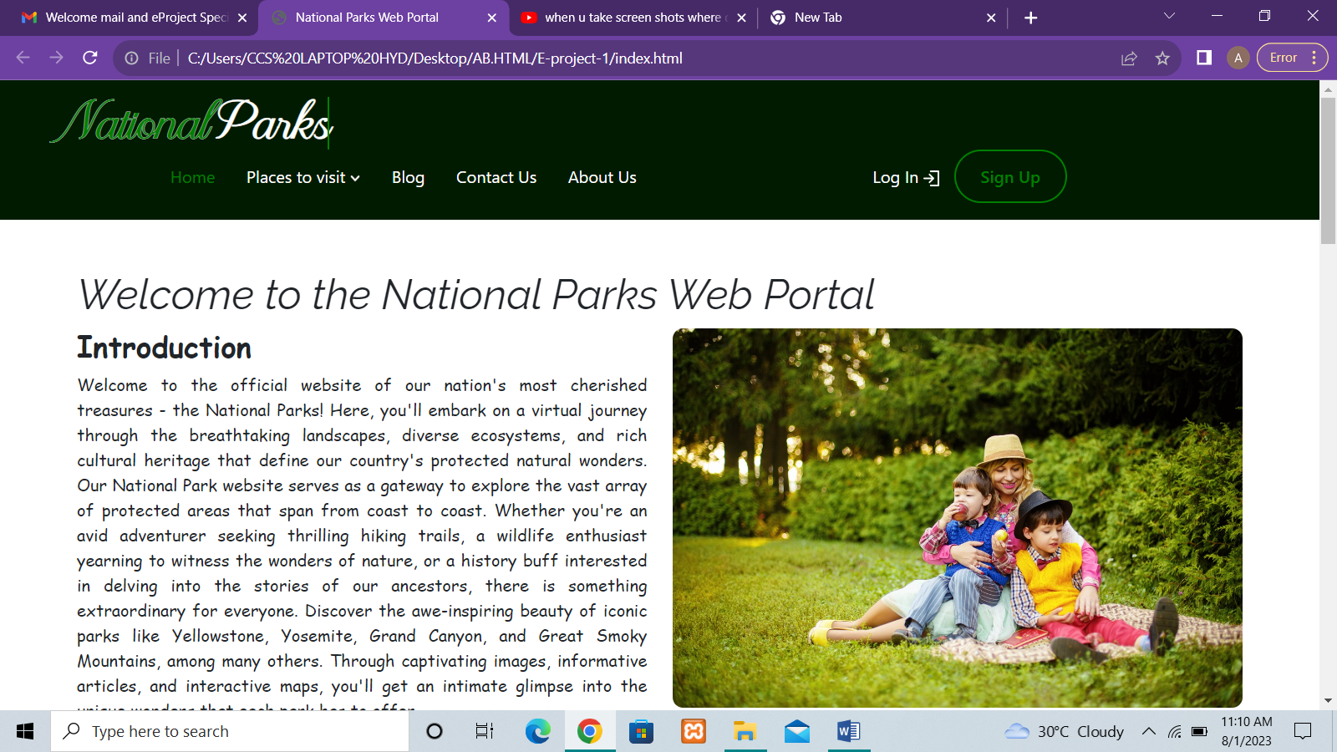

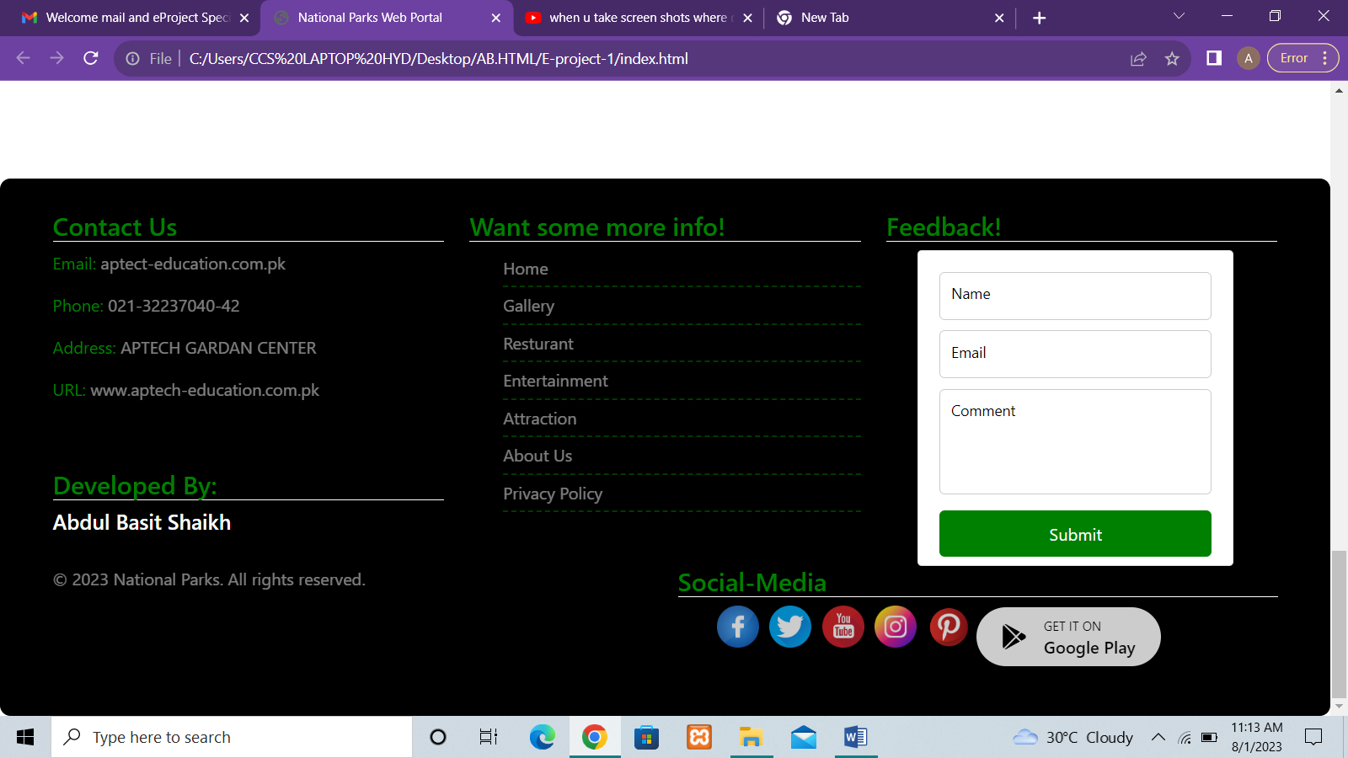

Other Pages

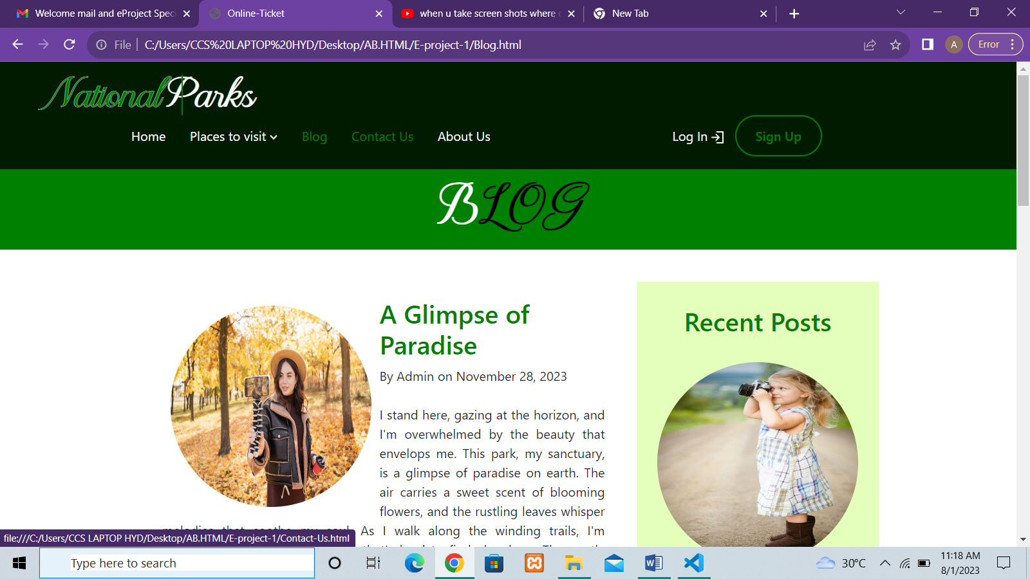

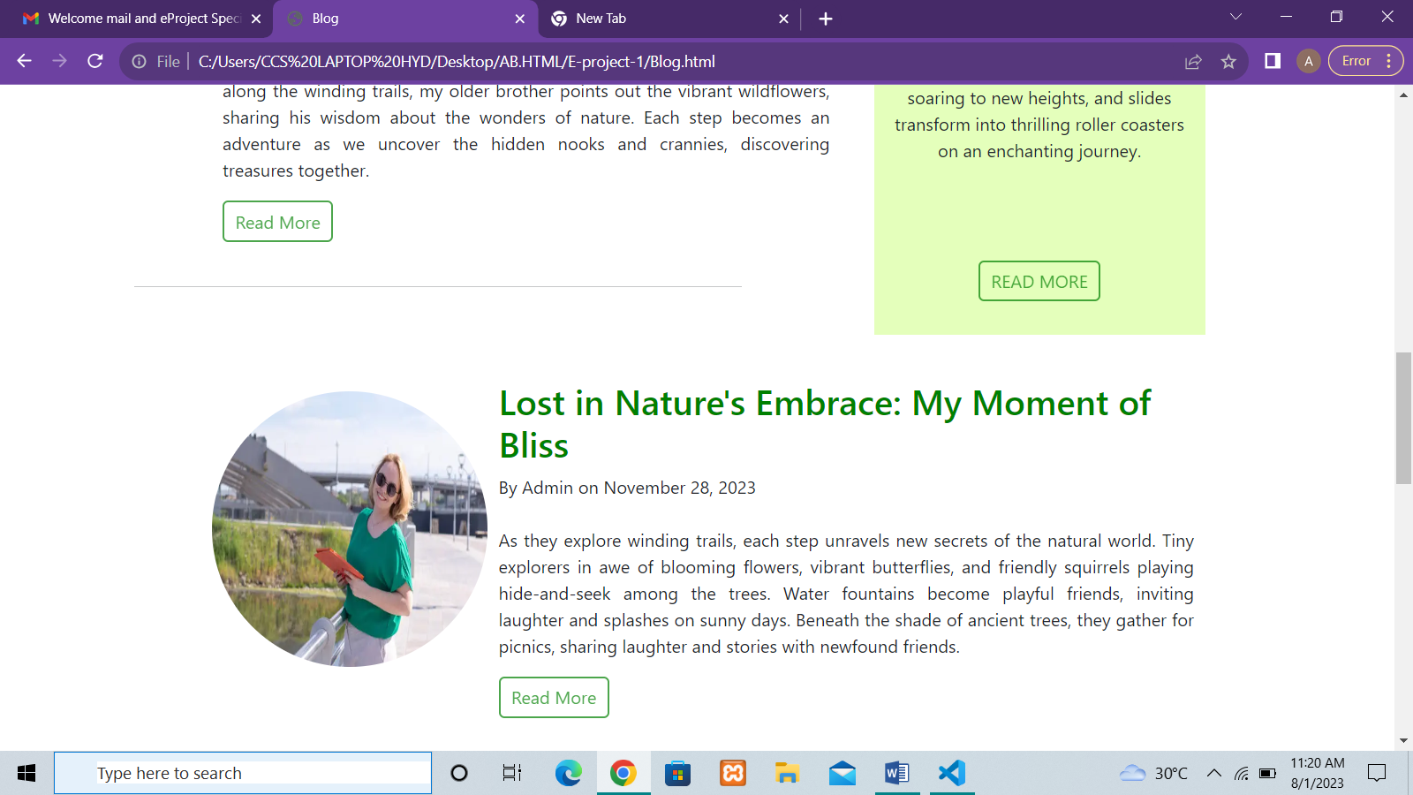

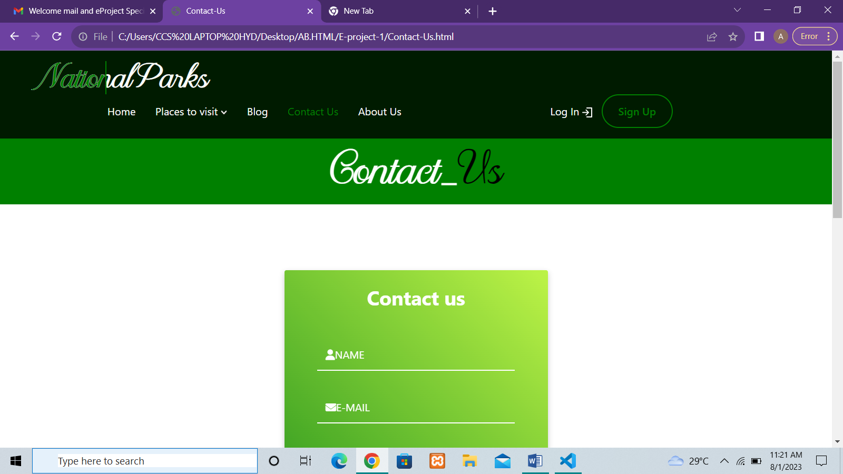

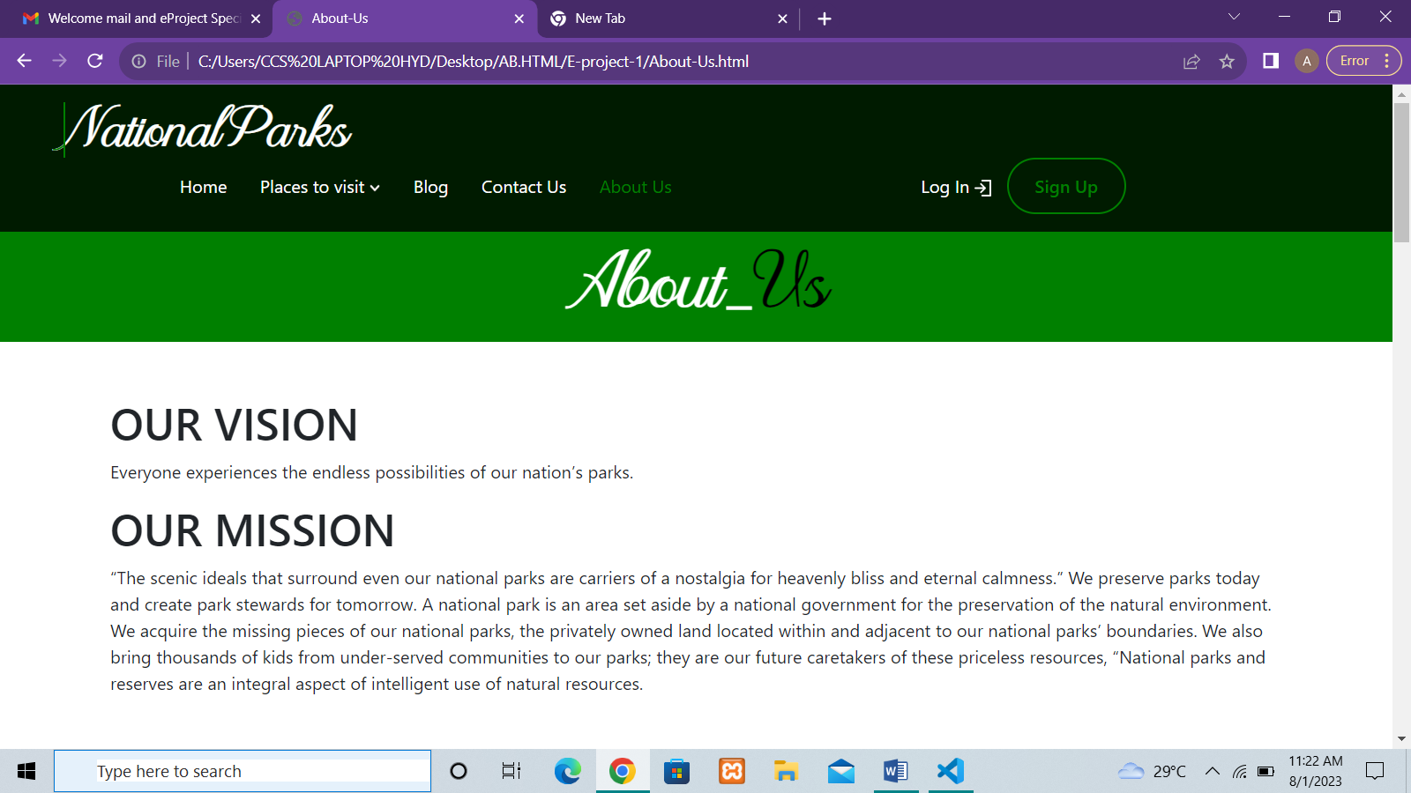

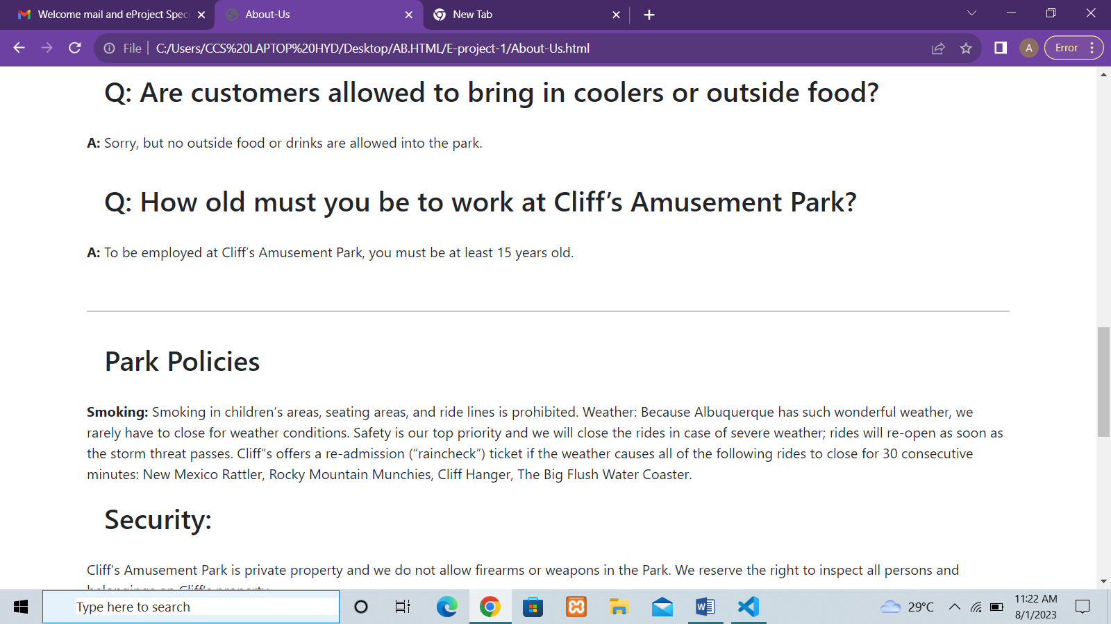

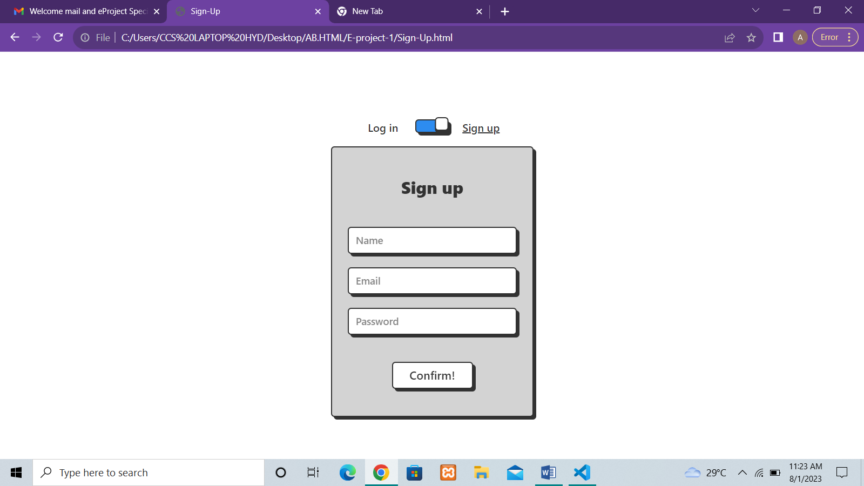

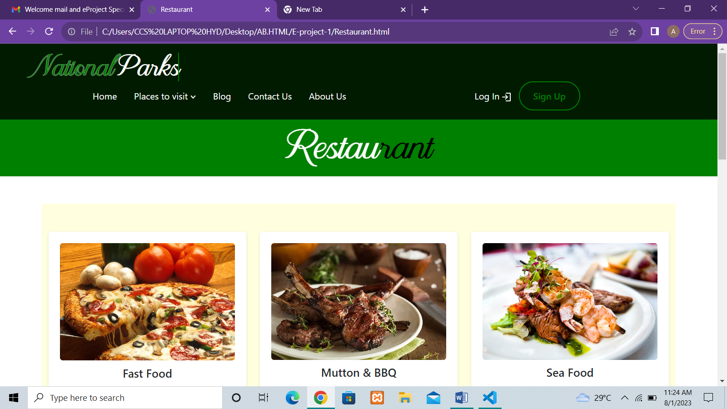

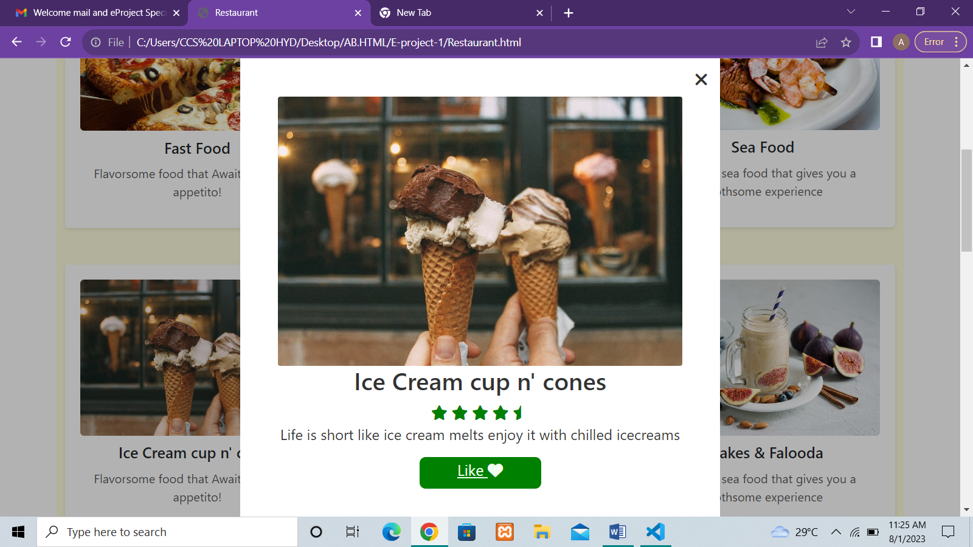

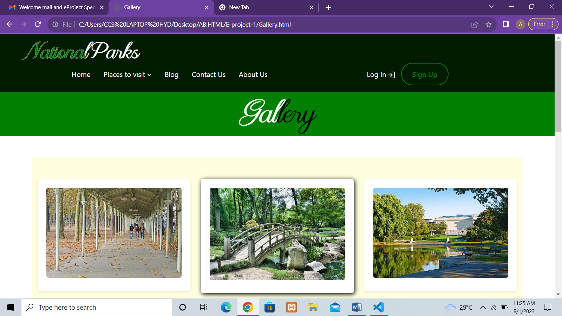

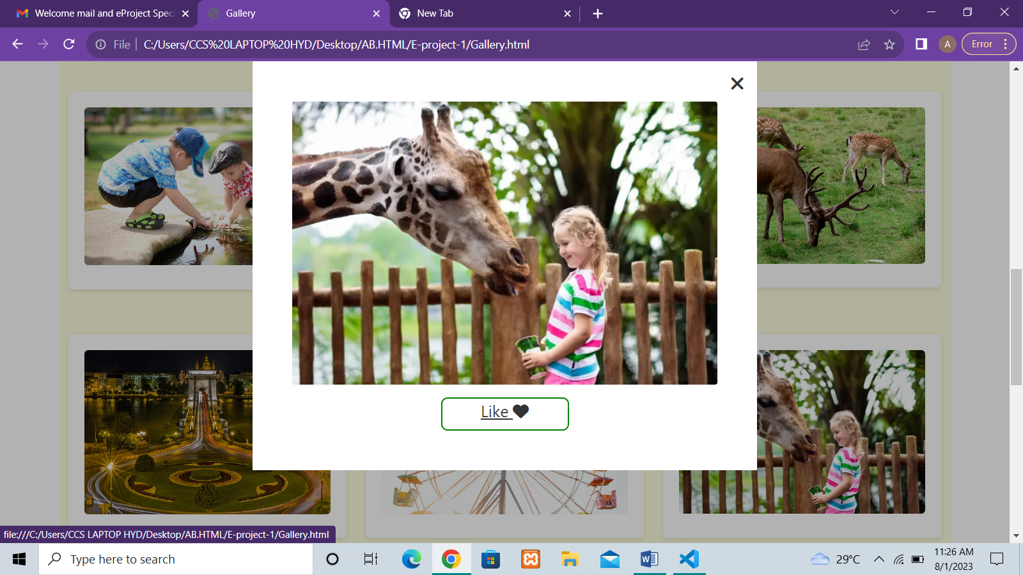

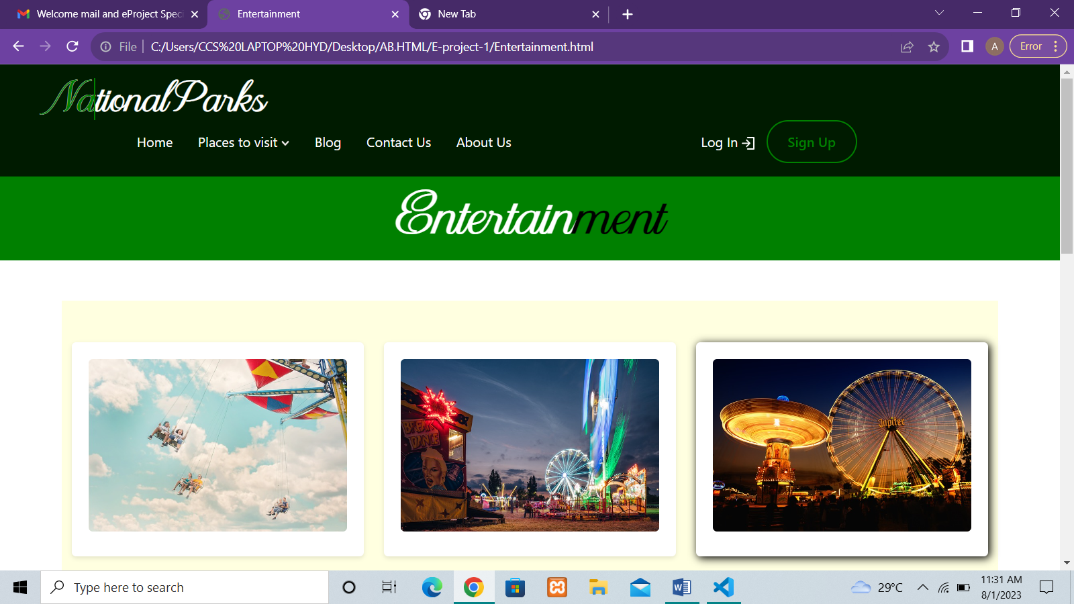

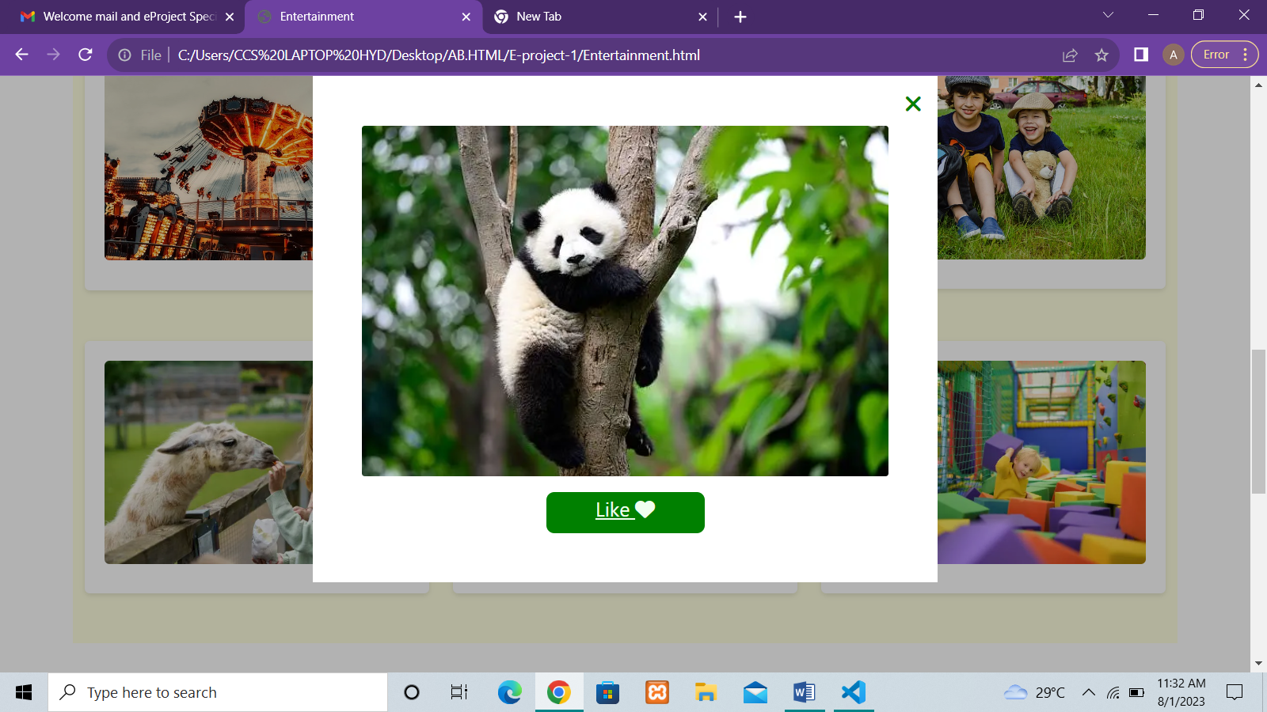

SOURCE CODE

<!DOCTYPE html>

<html>

<head>

  <title>National Parks Web Portal</title>

  <meta name="viewport" content="width=device-width, initial-scale=1.0">

  <link rel="stylesheet" href="https://cdnjs.cloudflare.com/ajax/libs/font-awesome/5.15.3/css/all.min.css" >

  <link rel="stylesheet" href="https://cdnjs.cloudflare.com/ajax/libs/font-awesome/6.4.0/css/all.min.css" integrity="sha512-iecdLmaskl7CVkqkXNQ/ZH/XLlvWZOJyj7Yy7tcenmpD1ypASozpmT/E0iPtmFIB46ZmdtAc9eNBvH0H/ZpiBw==" crossorigin="anonymous" referrerpolicy="no-referrer" />

  <link rel="preconnect" href="https://fonts.googleapis.com">

  <link rel="preconnect" href="https://fonts.gstatic.com" crossorigin>

  <link href="https://fonts.googleapis.com/css2?family=Raleway:ital@1&family=Rock+Salt&display=swap" rel="stylesheet">

  <link rel="stylesheet" href="index.css">

  <!-- Include Bootstrap CSS -->

  <link rel="stylesheet" href="https://cdn.jsdelivr.net/npm/bootstrap@5.0.0-beta3/dist/css/bootstrap.min.css">

  <script src="https://code.jquery.com/jquery-3.6.0.min.js"></script>

  <script src="index.js"></script>

</head>

Thank you